Q1)
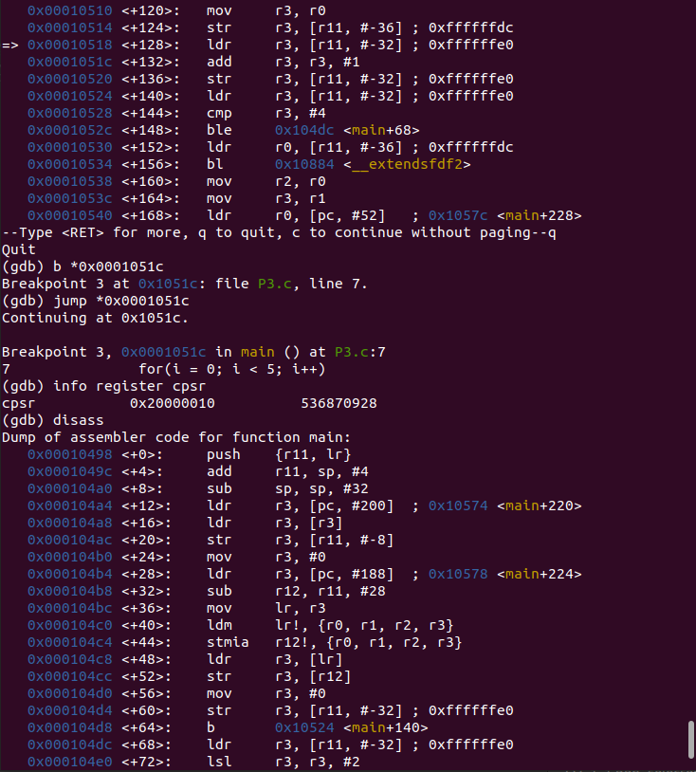
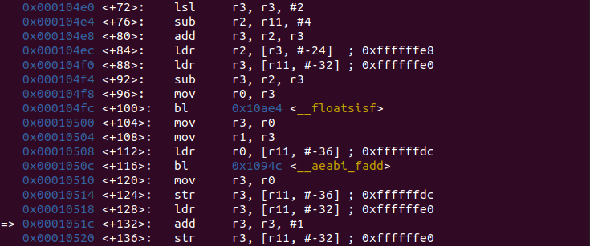

Q2)
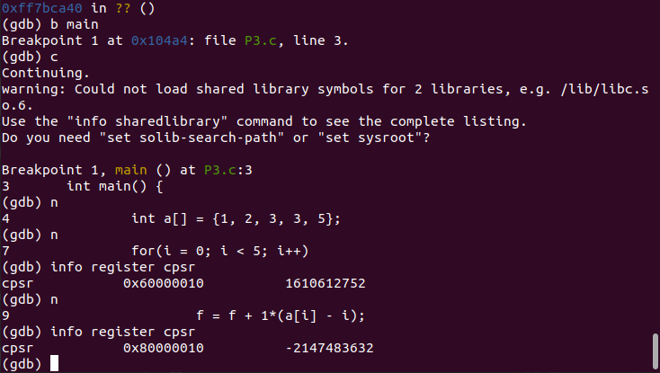

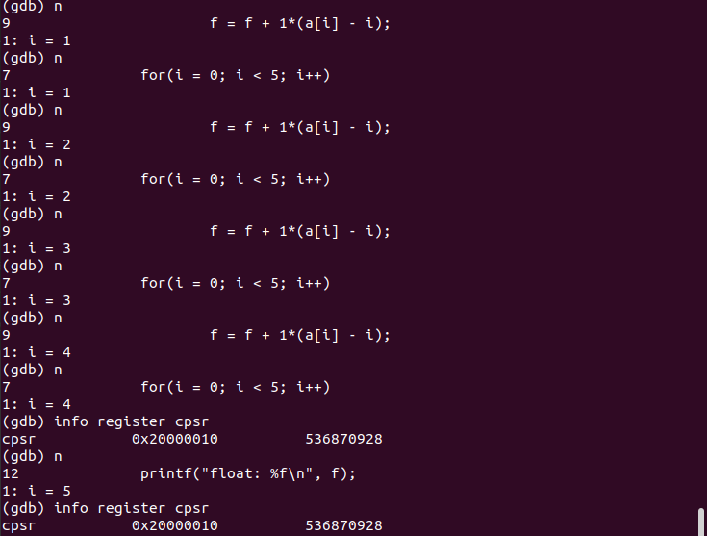
Q3)

Q1) CPSR value is 0x20000010,
which is 0010 0000 0000 0000 0000 0000 0001 0000
31st bit = N = 0
20th bit = Z = 0
29th bit = C = 1
28th bit = V = 0

Q2) CPSR value is 0x60000010,
which is 0110 0000 0000 0000 0000 0000 0001 0000
31st bit = N = 0
20th bit = Z = 1
29th bit = C = 1
28th bit = V = 0

Q3) CPSR value is 0x20000010,
which is 0010 0000 0000 0000 0000 0000 0001 0000
31st bit = N = 0
20th bit = Z = 0
29th bit = C = 1
28th bit = V = 0

